**Meta-Programming**

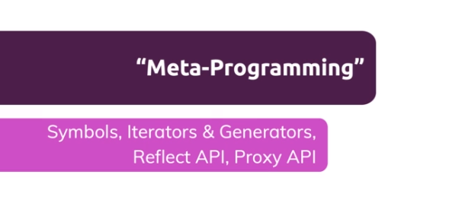

**Understanding Symbols**

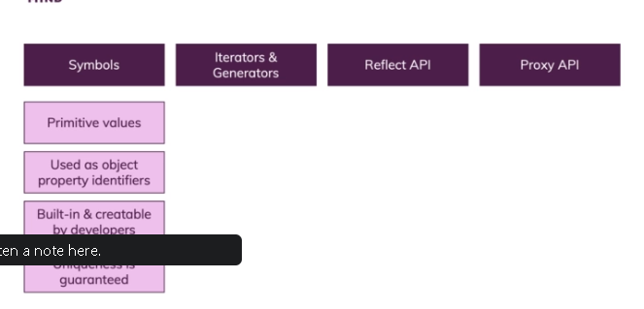

https://paper-attachments.dropbox.com/s_4C5E2D822C40331BBADFC8702AC3CB4D2492F387A9C67866A1D2CABBCD59A5D5_1633940753163_screenshot-www.udemy.com-2021-10-11-13-55-29-558.png

https://paper-attachments.dropbox.com/s_4C5E2D822C40331BBADFC8702AC3CB4D2492F387A9C67866A1D2CABBCD59A5D5_1633940757303_screenshot-www.udemy.com-2021-10-11-13-55-41-710.png

**Understanding Iterators**

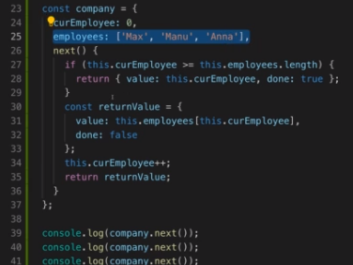

**Generators Summary & Built-in Iterables Examples**

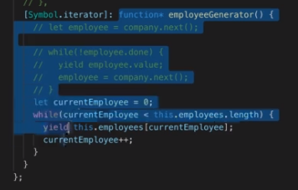

**The Reflect API**

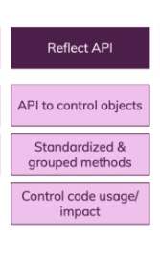

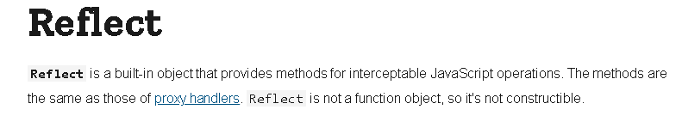

**The Proxy API and a First "Trap"**

